Vocabulary: Triangle Angle Sum

Vocabulary

- Exterior angle – an angle formed by one side of a polygon and the extension of an adjacent side.
interior
angle
exterior angle
A
B
C
1
- For example, ∠1 is an exterior angle of ΔABC shown to the right.

- Interior angle – an angle formed by two sides of a polygon that share an endpoint.
- For example, the interior angles of ΔABC above are ∠ABC, ∠BCA, and ∠CAB.
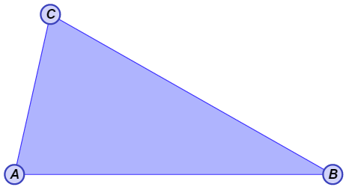

- Triangle – a polygon with three sides.

