Vocabulary: Triple Beam Balance

Vocabulary

- Fulcrum – the pivot point of a lever.

- Lever – a simple machine made of a stiff beam that pivots on a fulcrum.
  - The farther an object is from the fulcrum, the greater the downward force on the beam.
  - Because of this fact, a heavy object placed near the fulcrum can be balanced by a lighter object placed farther from the fulcrum.

- Mass – the amount of matter in an object.
  - In the metric system, the basic unit of mass is the gram (g). A paper clip has a mass of about one gram.
  - Mass is similar to weight but it is not exactly the same. Your weight depends on the gravity of the planet you are on. If you went to the Moon, your mass (amount of matter that makes you up) would be the same, but your weight would be much less than on Earth.

- Rider – a weight used to measure mass on a triple beam balance.
  - Riders slide along rider beams in the balance. The farther the rider is from the fulcrum of the balance, the greater the downward force it exerts on the beam, and the greater the upward force on the balance.
  - A triple beam balance has 100-gram, 10-gram, and 1-gram riders.

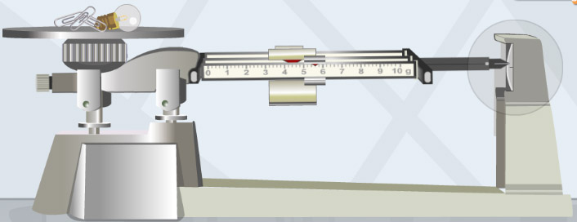
- Triple beam balance – an instrument that uses a set of three sliding riders to balance an unknown weight on the pan.
  - A standard triple beam balance can measure objects to a precision of 0.1 grams.
  - A triple beam balance works on the principle of the lever. As the riders move farther to the right (away from the fulcrum), they exert a greater downward force on the beam (and upward force on the pan).

