Name: Date:

Student Exploration: Modeling and Solving
Two-Step Equations

Vocabulary: equation, solution, solve

Prior Knowledge Questions (Do these BEFORE using the Gizmo.)
Your car breaks down on the highway, and you need to have it towed to a garage. A towing company charges $50 plus $4 per mile.

- Write an equation for the cost to have a car towed.

Explain.

- If the bill was $138, how far were you towed? Explain.

Gizmo Overview
An equation is a mathematical sentence stating that two expressions are equal. In the Modeling and Solving Two-Step Equations Gizmo, you can model an equation using x-cups and unit counters, and then solve it with the help of step-by-step instructions. To solve an equation is to find its solution – the value or values that make the equation true.

Here’s how the Gizmo looks at first:

The equation to solve is shown here. Click New for additional equations.
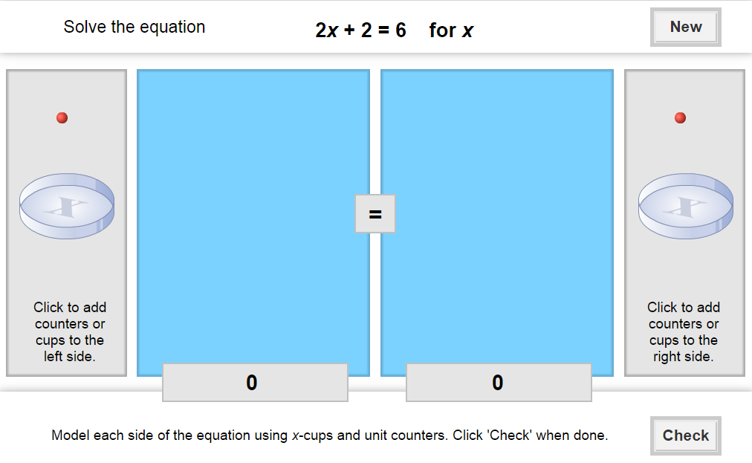
Click on x-cups and unit counters to model the right side of the equation.
Click on x-cups and unit counters to model the left side of the equation.

Feedback and instructions are given at the bottom.
Click Check to see if you have done each step correctly.

Activity:  Solving an equation | Get the Gizmo ready:  - You should see the equation 2x + 2 = 6. If not, click Refresh in your browser.

- When you begin, you should see the equation 2x + 2 = 6 at the top of the Gizmo. The x-cups represent the variable, x, and the unit counters represent the constant.

- How many of each are used to model “2x + 2”? x-cups: counters:

- How many of each are used to model “6”? x-cups: counters:

- Drag the appropriate number of x-cups and unit counters to each side of the equation. Click the Check button to make sure that your model is correct.

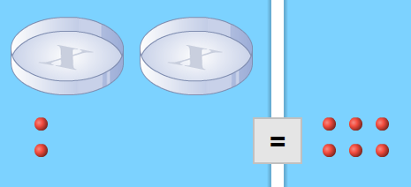
- To isolate the 2x term, how many counters do you need to remove from each side?
- Click the counters to isolate 2x. What equation do you have now? Click Check.
- Finally, divide the remaining counters so that there is an equal number in each x-cup. How many counters did you place in each cup?
- What is the solution to the equation? Click Check to verify your solution.

- Click New to try another equation. Model and solve this equation in the Gizmo.

- What equation were you given?

- Explain how you modeled and solved the equation.

- What is the solution? Click Check to confirm this.

- In the space to the right, substitute your solution for x in the original equation and simplify. If your solution is correct, this value of x should make the equation true.

- Click New to try additional equations using the Gizmo.
(Activity continued on next page)
Activity (continued from previous page)

- Solve each equation below. Show your work. Check your solution using substitution.

- 2x + 6 = 12

- 17 = 3x + 5

- 29 = 4x + 1

- 35 = 8x + 19

- 3x + 14 = 47

- 6x – 9 = 39

- Write two different two-step equations whose solutions are x = 8.

- Equation 1: Equation 2:

- Explain how you found those.

