Name: ______________________________________ Date: ________________________

Student Exploration: Uniform Circular Motion

Vocabulary: acceleration, centripetal acceleration, centripetal force, Newton’s first law, Newton’s second law, uniform circular motion, vector, velocity

Prior Knowledge Questions (Do these BEFORE using the Gizmo.)
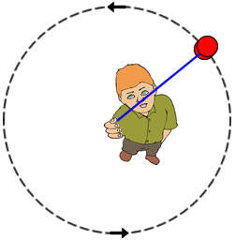
- A boy is whirling a yo-yo above his head in a counter-clockwise direction. At the exact moment shown at left, he lets go of the string. In which direction will the yo-yo travel? Draw an arrow on the image to show the yo-yo’s direction.

- Do you think the released yo-yo’s path will be straight or curved? Explain. _________________________________
_______________________________________________

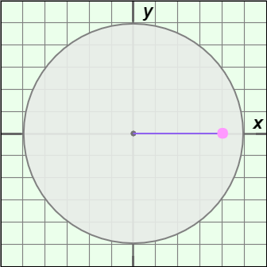
Gizmo Warm-up
The Uniform Circular Motion Gizmo shows a pink puck that is floating above a circular air table. The puck is held to the center of the table by a string so that it travels in a circle at a constant speed.

Check that the radius is 8.0 m and the mass is 5.0 kg. Set the velocity to 5.0 m/s.

- Turn on Show puck position (m). What are the coordinates of the puck’s position? __________________

- Click Play (), and then click Pause () when the puck is close to the y-axis.

What is the puck’s position now? __________________

- Click Reset (). Select the BAR CHART tab and select Velocity from the dropdown menu. The three bars represent the magnitude, the x component, and the y component of the puck’s velocity.

- Click Play. Does the magnitude of the velocity change over time? _______________

- Do the x and y components of the velocity change over time? _______________

Activity A:  Velocity, acceleration, and force | Get the Gizmo ready:  - Click Reset.  - Select the DESCRIPTION tab.  - Turn on Show velocity and acceleration vectors. | 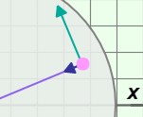

Introduction: Velocity is a vector quantity that describes both the speed and direction of an object’s motion. Vectors are represented by arrows. While the speed of the puck is constant, its direction changes continually as it travels in a circle. Because its direction is changing, the puck undergoes acceleration even though its speed is constant.

Question: How is the velocity of a revolving body related to its acceleration?

- Observe: On the SIMULATION pane, observe the directions of the velocity (green) and acceleration (purple) vectors.

- What do you notice? __________________________________________________

___________________________________________________________________

- Click Play. What do you notice about the vectors as the puck moves in a circle?

___________________________________________________________________

___________________________________________________________________

- Infer: Newton’s second law states that a force will cause objects to accelerate in the direction of the force.

- Given the fact that the puck is accelerating, what can you conclude? ____________

___________________________________________________________________

- What is the direction of the force on the puck as it travels in a circle? ____________

___________________________________________________________________

- Compare: Think about the force that causes a planet to orbit the Sun and the direction of this force. How does the puck on the table relate to a planet orbiting the Sun? What forces are acting on the puck and what forces are acting on the planet?

_________________________________________________________________________

_________________________________________________________________________

_________________________________________________________________________

(Activity A continued on next page)
Activity A (continued from previous page)

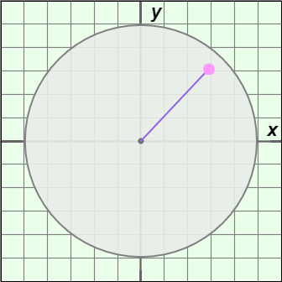
- Infer: Newton’s first law states that an object will continue at the same velocity (speed and direction) unless acted upon by an unbalanced force. Click Pause when the puck is in approximately the position shown at right. Imagine at this moment the string connecting the puck to the center is cut.

- Is any force acting on the puck now? ______________

- Draw an arrow on the image to represent the direction of the puck’s motion.

- Would the path of the puck be straight or curved? ___________________________

- Apply: If the string connecting the puck to the center is cut, there will be no net force on the puck. (The force of gravity is offset by the turntable.) The puck will not accelerate or change direction, so it will move at a constant speed in the direction it was moving at the time the string was cut.

How does this relate to the boy whirling a yo-yo given at the start of this Exploration sheet?

_________________________________________________________________________

_________________________________________________________________________

- Think and discuss: If you are sitting in the back seat of a car that makes a hard left turn, you will feel pushed toward the right side of the car. Why does your body move to the right?

_________________________________________________________________________

_________________________________________________________________________

_________________________________________________________________________

_________________________________________________________________________

Activity B:  Centripetal acceleration | Get the Gizmo ready:  - Click Reset.  - Set the radius to 2.0 m, the mass to 1.0 kg, and the velocity to 10.0 m/s. | 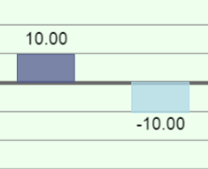

Introduction: The acceleration toward the center that keeps objects in uniform circular motion (circular motion at a constant speed) is called centripetal acceleration. An understanding of centripetal acceleration was one of the key elements that led to Newton’s formulation of the law of universal gravitation.

Question: How is centripetal acceleration related to radius, mass, and velocity?

- Record: Select the BAR CHART tab, select Acceleration from the dropdown menu, and turn on Show numerical values. The bar on the left shows the magnitude of the acceleration, or |a|. The units of acceleration are meters per second per second, or m/s².

What is the current magnitude of the acceleration? ________________________________

- Predict: How do you think the magnitude of the acceleration will depend on radius, mass, and velocity? Record your predictions by completing each sentence.

When the radius increases, the centripetal acceleration will _________________________.

When the mass increases, the centripetal acceleration will _________________________.

When the velocity increases, the centripetal acceleration will ________________________.

- Gather data: Keeping the mass at 1.0 kg and the velocity at 10.0 m/s, record the magnitude of centripetal acceleration for each given radius value. Include units.

Radius: | 2.0 m | 4.0 m | 6.0 m | 8.0 m | 10.0 m
Acceleration:
Radius factor:
Acceleration factor:

- Calculate: To calculate the radius factor, divide each radius by the original radius (2.0 m). To calculate the acceleration factor, divide each acceleration value by the original acceleration (50.00 m/s²).

- Analyze: How does the acceleration change when the radius is multiplied by x? __________

_________________________________________________________________________

(Activity B continued on next page)
Activity B (continued from previous page)

- Explore: Move the mass slider back and forth. Does the puck’s mass have any effect on its acceleration? Explain. _______________________________________________________
_________________________________________________________________________

- Gather data: Set the radius to 2.0 m and the velocity to 1.0 m/s. Keeping the radius the same, record the magnitude of centripetal acceleration for each given velocity. Include units.

Velocity: | 1.0 m/s | 2.0 m/s | 3.0 m/s | 4.0 m/s | 5.0 m/s
Acceleration:
Velocity factor:
Acceleration factor:

- Calculate: To calculate the velocity factor, divide each velocity by the original velocity
(1.0 m/s). To calculate the acceleration factor, divide each acceleration value by the original acceleration (0.50 m/s²).

- Analyze: How does the acceleration change when the velocity is multiplied by x? _________

_________________________________________________________________________

- Make a rule: Based on your investigations, create an equation for centripetal acceleration (a_{c}) based on the velocity and radius. Test your equation using the Gizmo.

a_{c} =

- Apply: Without using the Gizmo, use your equation to calculate the acceleration of a puck that is in uniform circular motion with a radius of 3.0 m and a velocity of 9.0 m/s: _________
Check your answer with the Gizmo.

- Challenge: Newton’s second law states that force is equal to the product of mass and acceleration: F = ma. Based on Newton’s second law, what is the centripetal force (F_{c}) on a puck in uniform circular motion with mass m and velocity v?

F_{c} =

