Vocabulary: Waves

Vocabulary

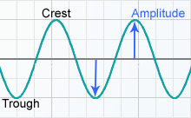
- Amplitude – the maximum distance a point is moved from its rest position when a wave passes through.
  - For a transverse wave, the amplitude is the distance a point is moved up or down when a wave passes through.
  - For a longitudinal wave, the amplitude is the distance a point is moved left or right as the wave passes through.

- Compression – a part of a longitudinal wave where the particles in the medium are pushed together.

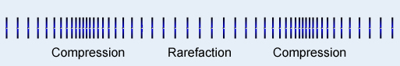

- Crest – the highest part of a wave.

- Frequency – the number of times something occurs in a given period of time.
  - The frequency of a wave is equal to the number of waves that pass a point each second.
  - The unit of frequency is the hertz (Hz). One hertz is one event per second.
  - If the speed is held constant, shorter wavelengths will correspond to higher frequencies, and longer wavelengths will correspond to lower frequencies.

- Linear mass density – the amount of mass per unit of length.
  - Linear mass density is measured in kilograms per meter.
  - For example, a 10-meter rope with a mass of 13 kilograms has a linear mass density of 1.3 kg/m.

- Longitudinal wave – a wave in which the motion of the medium is in the same direction as the wave.

- Medium – a substance through which waves can travel.

- Period – the time required for a single event to occur.
  - The period of a wave is the time required for one full wave to pass a location.

- Power – the rate at which work is done.
  - Power is equivalent to the amount of energy produced in a given time.
  - The unit of power is the watt (W). One watt is equal to one joule per second.

- Rarefaction – a part of a longitudinal wave where the particles in the medium are spread apart.

- Transverse wave – a wave in which the motion of the medium is perpendicular to the direction of the wave.

- Trough – the lowest part of a wave.

- Wave – a repeating motion that travels through a medium.
    - Particles in the medium move up-and-down and/or back-and-forth as the wave passes through.
    - The particles in the medium do not move permanently when the wave passes through. After the wave passes, the particles eventually move back to their original rest positions.
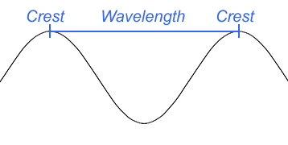
- Wavelength – the distance between neighboring crests, neighboring troughs, or any other neighboring equivalent points of a wave.
  - Wavelength is represented by the Greek letter λ (lambda).

- Wave speed – the distance a wave travels in a given amount of time.
  - Wave speed (v) is equal to the product of a wave’s frequency (f) and its wavelength (λ): v = λ • f.

