Vocabulary: Weathering

Vocabulary

- Abrasion – a type of weathering in which the surface of a rock is scratched and physically worn away.

- Chemical weathering – a process in which rocks are transformed and worn away by chemical reactions.
  - Examples of chemical weathering include the dissolving of limestone and the transformation of various minerals into clay.

- Clay formation – chemical weathering of minerals into clay.
  - Clay is generally much softer than the original minerals. When it rains, clay absorbs water and expands, which can break the rock apart.
  - Clay formation is also called hydrolysis.

- Climate – the average weather conditions in an area.
  - Climate includes factors such as average temperature, precipitation (rain and snow), humidity, cloud cover, and wind.

- Dissolving – a process in which a solid becomes a part of a liquid to form a solution.
  - For example, limestone can be dissolved by acidic water, forming caves and other features.
  - Dissolving of limestone is also called carbonation or solution weathering.
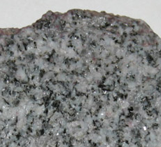
Granite

- Frost wedging – a process of mechanical weathering in which water seeps into cracks and freezes. Because water expands when it freezes, the ice can put pressure on the rock, causing the crack to enlarge.

- Granite – a hard rock made of interlocking crystals of quartz, feldspar, mica, and other minerals.
  - Granite is an igneous rock. It forms from the slow cooling of magma deep below Earth’s surface.
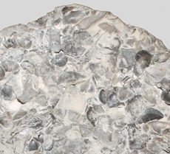
Limestone

- Limestone – a rock made of calcium carbonate.
  - Limestone is a sedimentary rock. It is made up of the cemented skeletons and shells of marine organisms, including coral.

- Mechanical weathering – a process in which rocks are physically worn away without changing their chemical composition.
  - Examples of mechanical weathering include abrasion, frost wedging, exfoliation, and salt weathering.
  - Mechanical weathering is also called physical weathering.
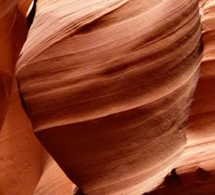
Sandstone

- Rusting – a type of chemical weathering in which iron reacts with oxygen to produce iron oxide, or rust.
  - Rusting is also called oxidation.
  - Rust is porous and flaky compared to the original iron and can cause rocks to fall apart.

- Sandstone – a rock made from cemented sand grains.
  - Sandstone can form from sand grains that pile up on beaches, in shallow areas, and in deserts.
  - Some sandstones are mostly pure quartz and are very resistant to chemical weathering. Other sandstones contain minerals such as feldspar that can weather into clay.
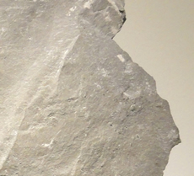
Shale

- Shale – a rock that forms from compacted mud and silt.
  - Shale forms when sediments deposited under water are compacted.
  - Shale is a relatively soft rock that breaks down more quickly than other rocks.

- Weathering – a process in which rocks at Earth’s surface are gradually broken down into smaller pieces and eventually into soil.

