Name: Date:

**Student Exploration: Zap It! Game**

**Vocabulary:** parabola, quadratic function

**Prior Knowledge Questions** (Do these BEFORE using the Gizmo.)

The equation of the line shown is *y* = 2*x* + 3.

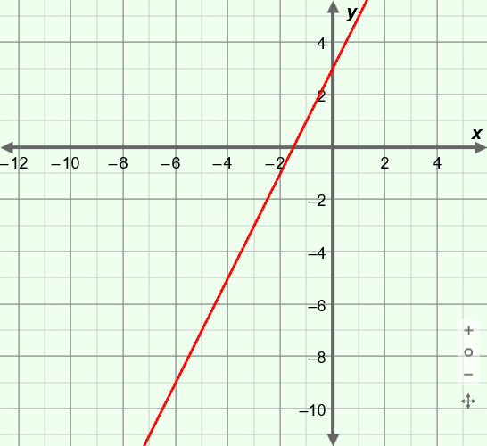

1. If you wanted the line to intersect more points, how would you change the slope of the line?

1. How would you change the *y*-intercept?

**Gizmo Warm-up**

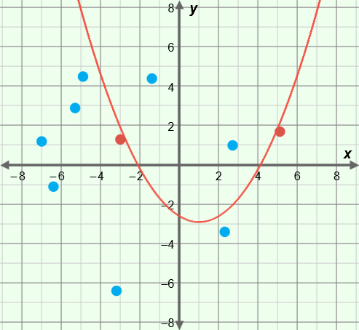In the *Zap It!* Gizmo, you will see how many points you can hit (or “zap”) with a **parabola** by changing the values in a **quadratic function**. You can choose polynomial form, *y* = *ax*2 + *bx* + *c*, or vertex form, *y* = *a*(*x* – *h*)2+ *k*.

With **Polynomial form** selected, be sure that the sliders are set to the default values: ***a*** to 1, ***b*** to 0, and ***c*** to 0. (To quickly set a slider to a value, type the value in the box to the right of the slider and press **Enter**.)

1. Click **Reset – random points**. Then click **Graph it!** to graph *y* = *x*2. The “zapped” points are in red.
   1. How many points did this curve “zap”?
   2. How do you need to change the parabola to zap more points?

1. Click **Keep trying**. Drag the sliders, and click **Graph it!** How many did you zap now?

Keep trying! The goal is to zap as many points as you can, in as few attempts as possible.

To start a new game, click either **Reset – random points** or **Reset – perfect fit**.

|  |  |  |
| --- | --- | --- |
| **Activity A:**  **Polynomial form** | Get the Gizmo ready:   * Be sure **Polynomial form** is selected. * Click **Reset – random points**. |  |

1. Play the “Random points” game several times. Record how many points you zap each time.

|  |  |  |  |  |  |  |
| --- | --- | --- | --- | --- | --- | --- |
| **Game** | **Attempt 1** | **Attempt 2** | **Attempt 3** | **Attempt 4** | **Attempt 5** | **Most**  **zapped** |
| 1 |  |  |  |  |  |  |
| 2 |  |  |  |  |  |  |
| 3 |  |  |  |  |  |  |
| 4 |  |  |  |  |  |  |

1. Click **Reset – perfect fit**. In this game, you can actually zap all 10 points. The challenge is, how many tries will it take you to zap all 10? (Note: The points in the Gizmo are “fat” so there are several different graphs that will zap all 10 points.)

Game 1: It took attempts to zap all 10 points.

Game 2: It took attempts to zap all 10 points.

Game 3: It took attempts to zap all 10 points.

Game 4: It took attempts to zap all 10 points.

Play the “perfect fit” game several more times, in **Polynomial form** mode. What’s your best score (fewest attempts to zap all 10 points)?

1. The parabola graphed here is *y* = *x*2 (*a* = 1, *b* = 0, and *c* = 0). How would you change the values in *y* = *ax*2 + *bx* + *c* to zap more points? Explain why.

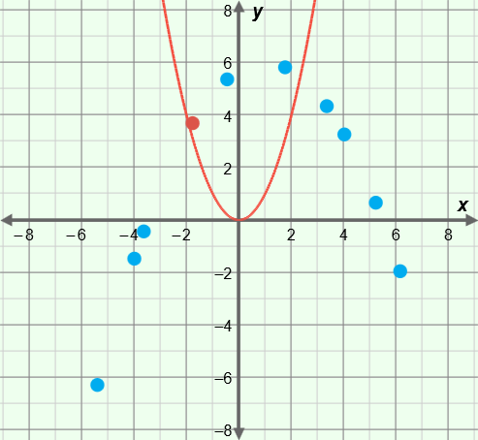

|  |  |  |
| --- | --- | --- |
| **Activity B:**  **Vertex form** | Get the Gizmo ready:   * Select **Vertex form**. * Click **Reset – random points**. |  |

1. Play the “Random points” game several times. Record how many points you zap each time.

|  |  |  |  |  |  |  |
| --- | --- | --- | --- | --- | --- | --- |
| **Game** | **Attempt 1** | **Attempt 2** | **Attempt 3** | **Attempt 4** | **Attempt 5** | **Most**  **zapped** |
| 1 |  |  |  |  |  |  |
| 2 |  |  |  |  |  |  |
| 3 |  |  |  |  |  |  |
| 4 |  |  |  |  |  |  |

1. Click **Reset – perfect fit**. In this game, you can actually zap all 10 points. The challenge is, how many tries will it take you to zap all 10? (Note: The points in the Gizmo are “fat” so there are several different graphs that will zap all 10 points.)

Game 1: It took attempts to zap all 10 points.

Game 2: It took attempts to zap all 10 points.

Game 3: It took attempts to zap all 10 points.

Game 4: It took attempts to zap all 10 points.

Play the “perfect fit” game several more times, in **Vertex form** mode. What’s your best score (fewest attempts to zap all 10 points)?

1. The parabola graphed here is *y* = *x*2 (*a* = 1, *h* = 0, and *k* = 0). How would you change the values in *y* = *a*(*x* – *h*)2+ *k* to zap more points? Explain why.

