Vocabulary: Zap It! Game

dictionary2

**Vocabulary**

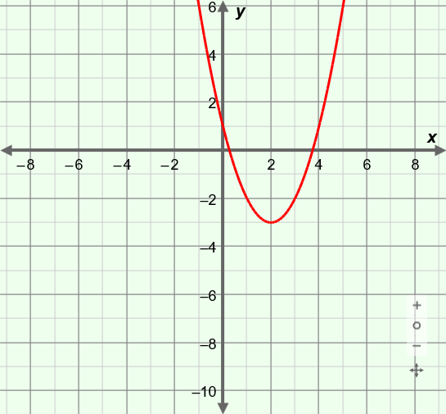

**(2, –3)**

* Parabola – the graph of a quadratic function.
* Quadratic function – a function in which *y* depends on the square of *x*.
* Graphs of quadratic functions are *parabolic*.
* The polynomial form of a quadratic function is *y* = *ax*2 + *bx* + *c*.
  + In polynomial form, the function graphed above is *y* = *x*2 – 4*x* + 1.
* The vertex form of a quadratic function with a vertex at (*h*, *k*) is *y* = *a*(*x* – *h*)2+ *k*.
* In vertex form, the function graphed above is *y* = (*x* – 2)2 – 3, with its vertex at (2, –3).