Name: ______________________________________ Date: ________________________

Student Exploration: pH Analysis

Vocabulary: acid, acidic, alkaline, base, indicator, neutral, pH

Prior Knowledge Questions (Do these BEFORE using the Gizmo.)

- Acids are substances that produce hydrogen ions (H⁺) when dissolved in water. Lemon juice is an example of an acid.

  - What does lemon juice taste like? ________________________________________

  - What does it feel like if lemon juice gets in your eye? _________________________

- Bases are substances that produce hydroxide ions (OH⁻) when dissolved in water. Hand soap is an example of a base.

  - What does soap feel like? ______________________________________________

  - What does soap taste like? _____________________________________________

  - What does it feel like if soap gets in your eye? ______________________________
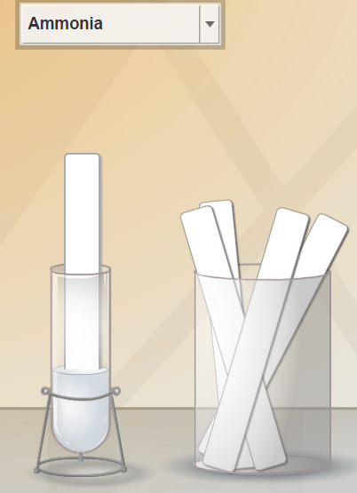

Gizmo Warm-up
The strength of an acid or base is measured on the pH scale. The term “pH” is short for “potential of hydrogen.” It is a measure of how many excess H⁺ ions there are in a solution. The pH scale runs from 0 to 14, with 0 representing the highest concentration of hydrogen ions. Acidic substances have a pH below 7, while alkaline substances (bases) have a pH above 7. Pure water has a pH of 7 and is considered neutral.

The pH Analysis Gizmo allows you to find the pH of a variety of liquids. In the Gizmo, check that the Substance in the tube is Ammonia, and click Test. Wait until the animation is finished.

- Indicators change color in acids or bases. What is the color of the pH paper? ___________

- Compare the paper to the pH color chart. What is the pH of ammonia? _____________

- Is ammonia acidic or alkaline? _____________

Activity A:  Measuring pH | Get the Gizmo ready:  - Click Reset.  - Check that the 0-14 paper is selected. | 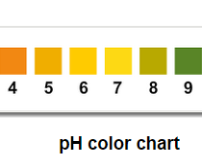

Goal: Find the pH of 18 common substances.

- Test: Use the Gizmo to find the pH of each of the available substances. Classify each substance as acidic (pH < 7), alkaline (ph > 7), or neutral (pH = 7).

0-14 pH indicator paper
Material in the tube | pH value | Acidic, alkaline, or neutral?
Baking soda
Bleach
Coffee
Cola
Drain cleaner
Hand soap
Juice (lemon)
Juice (orange)
Juice (tomato)
Milk
Milk of magnesia
Oven cleaner
Saliva (human)
Shampoo
Stomach acid
Vinegar
Water (distilled)
Water (ocean)

- Summarize: Compare all the acidic substances and all the alkaline substances.

    - In general, what types of substances tend to be acidic? _______________________

___________________________________________________________________

    - What types of substances tend to be alkaline? ______________________________

___________________________________________________________________

Activity B:  More accurate pH | Get the Gizmo ready:  - Click Reset.  - Select the 4.5-7.5 paper. | 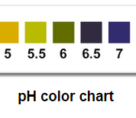

Goal: Find the pH of substances in a more accurate way.

- Test: Before you begin testing with the 4.5-7.5 paper, list the pH values of the substances below that you found using the 0-14 pH indicator paper. Then find the pH of each substance with the 4.5-7.5 paper.

4.5-7.5 pH indicator paper
Material in the tube | pH value (0 to 14 paper) | pH value (4.5 to 7.5 paper)
Coffee
Milk
Oven cleaner
Saliva (human)
Shampoo
Stomach acid
Water (distilled)

- Analyze: Compare the pH values in each column.

- How do these values compare? _________________________________________

___________________________________________________________________

- What is an advantage of using the 4.5-7.5 paper? ___________________________

___________________________________________________________________

- What is a disadvantage of using the 4.5-7.5 paper? __________________________

___________________________________________________________________

- Given the results from two kinds of indicator paper, which substances appear to be neutral (pH = 7)? _____________________________________________________

